How Is Alvarado Estates Doing? 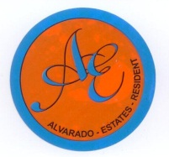
Hello Neighbors:

If you have an Association issue you would like addressed, your Board of Directors will do their best to address it in a timely manner. Just fill in the form below, completing each blank*, return it to me at alfredovalverde@cox.net and I will see that it gets to the proper Committee.
Please keep in mind that some matters require a decision on the part of the entire Board and will have to be placed on the agenda of the next meeting. For Board meeting dates, see http://www.alvaradoestates.org
As a member in good standing, you will be contacted noting the Board’s decision or action taken.

Thank you,
Alfredo C. Valverde Jr.
Alvarado Estates President
*For processing, all information below must be completed.

Date:
Member’s Name
Address
Lot Number
Daytime Phone
Evening Phone
E-Mail Address

This is my concern:
______________________________________________________________________________________________________________________________________________________________________________________________________________________________________________________________________________________________________________________________________________________________________________________________________________________________________________________________________________ _________________________________________________________________________________________________________________________________________________________________________________________________________________________________________________________________________________________________________________________________________________________________________________________________

